Checks and Questions FBB-BGan

Questions
- What is the terminal manufacturer and model? (Furuno=JRC for Firmware)
- What is the Firmware version used?
- What is the Launchpad version (if Launchpad is used)?
- Please identify your mobile (Card ICCID, IMSI, MSISDN)?
- In which country or region are you located?
- Is the current GPS Position up-to-date?
- Is your antenna signal strong and stable? How many bars?
- What kind of connection are you using (Background, Streaming, etc.)?
- Which operating system is used on the PC?
- Is there any device used between the terminal and the PC? If yes, what kind of device?
- What are the APN you tried to use?
- What is the service used? (username)
- Which interface is used (Ethernet, USB, WIFI, Bluetooth)?
- Did the terminal work before?
- Since when did the service stop working?
- What is the error code or error message?

Checks
- Check Mobile status in The Source, BSS, MMI (Radius).
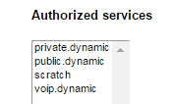
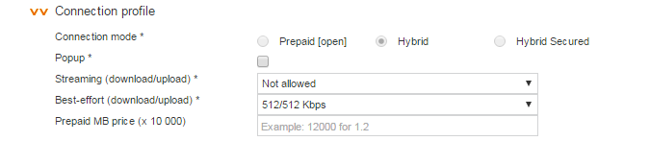
  - If the card is not active in BSS > Admin Team

- Check Filter in the MMI.
- Firewall > Traffic Control (OK) > see if filter or not
- Check Call records in The Source, MMI (IMSI needed, Session Log Details)
- Check the GPS position with the customer.
- Check the Antenna signal with the customer.
- Check the APN, services used with the customer.
- Dashboard/ Webinterface 192.168.0.1
  - Settings (Username: admin/ Password: 1234)
  - LAN
  - Network User Groups
  - Group enabled- edit
- Example of case notes:
  - 898709912414173457 no voice and data
  - Vessel Name TIN ZIREN
  - Activation TS+BSS+MMI ok
  - No filter, card currently not connected, no service per default.
  - CDRs TS: APN vizada.bgan.inmarsat.com, located Belgium, no error code in TS (normal release)
  - Only CDR from 25/7 (data only, no voice attempt visible)
  - CDRs MMI from 25/7 private.dynamic service, Background only
  - No error code
  - Technician already on board-see attached

